Maureen Casey
1234 Main St.
Cumming, GA 30024

Bob Smith
4321 First St
Miami, FL 33101

Re: Increasing Effiency with Computerization for Bob’s Home Repairs

Dear Bob,
I hope you are well. I'm reaching out to you regarding the computerization of some of Bob’s Home Repairs' manual processes to improve efficiency and allow you to scale your business. To maintain and increase profitibility, it's important to keep track of the following:

- Customers
  - Customer demographics
  - How much a customer was billed, has paid and the balances still owed
- Bids
  - How much the repairs cost per bid
  - What are the hourly costs for each repair
  - What materials are used and what are their costs
- Suppliers
  - Supplier demographics
  - Which materials does each supplier provide
  - How much are the suppliers are paid

The implementation of a computerized solution will allow you to spend more time in the field doing repairs, thereby increasing your efficiency and success. By automating the invoicing process, you'll know how much money is owed and how much should be coming in. Please find attached a preliminary software proposal with our suggestions.

I would like the opportunity to further discuss this proposal and determine what our company can do to meet your digital needs. Please let me know a day and time that would be convenient for you.

Thank you,
Maureen Casey

770-555-1212

Bob's Home Repairs Management Software Package

- Software Management System to include:
- Database with the following tables
- Customers table
  - Maintain demographics
- Customer Payments, Invoices and Customer Balances View tables
  - Generate customer invoices automatically
  - Record monthly customer payments and track balances owed
- Bids table
  - Record the bids that are sent to each customer
  - Each customer may have more than one bid
  - Includes hourly fees and materials costs
- Repairs table
  - Assign each repair to a bid
- Materials & Suppliers
  - Supplier demographics and which materials they supply are maintained
  - Ensure that materials are attributed to specific repairs
- Supplier Payments table
  - Maintain a record of your supplier payments to avoid missed deadlines

- Reporting Capabilities:
- Dashboards can be created from data gathered.
  - Financial information such as past due accounts for suppliers and customers
  - Year over year trending reports
  - Cost of good and services changes
  - Costs per rapair

- Additional Options:
- Forms can be created to allow simpler and automatic uploading of data
- Mobile access can be included for remote bid creation and payment acceptance

  - The E-R diagram clearly identifies the entities, relationships, and attributes that are detailed in the previous summary.
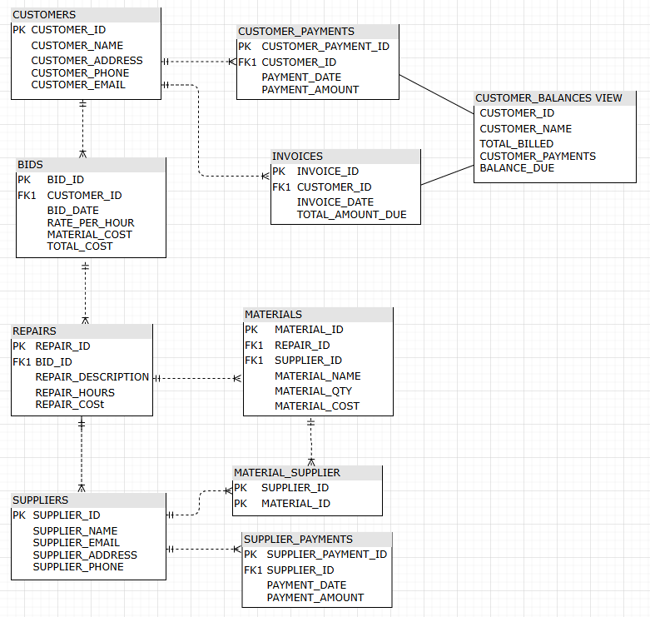

- The newly created tables align to the E-R. All tables are populated with five rows of sample data. Any constraints in the tables are commented in the SQL code.
CREATE TABLE SQL:
CREATE TABLE CUSTOMERS (
CUSTOMER_ID INT IDENTITY(1,1) PRIMARY KEY
,CUSTOMER_NAME VARCHAR(100)
,CUSTOMER_EMAIL VARCHAR(100)
,CUSTOMER_ADDRESS VARCHAR(1000)
,CUSTOMER_PHONE VARCHAR(20)
);

CREATE TABLE BIDS (
BID_ID INT IDENTITY(1,1) PRIMARY KEY
,CUSTOMER_ID INT FOREIGN KEY (CUSTOMER_ID) REFERENCES CUSTOMERS(CUSTOMER_ID) -- Foreign key constraint on customer_id
,BID_DATE DATE
,RATE_PER_HOUR MONEY
,MATERIAL_COST MONEY
,TOTAL_COST AS CAST((RATE_PER_HOUR + MATERIAL_COST) AS MONEY) PERSISTED --calculated field, but stored as value
);

CREATE TABLE CUSTOMER_PAYMENTS (
CUSTOMER_PAYMENT_ID INT IDENTITY(1,1) PRIMARY KEY
,CUSTOMER_ID INT FOREIGN KEY (CUSTOMER_ID) REFERENCES CUSTOMERS(CUSTOMER_ID) -- Foreign key constraint on customer_id
,PAYMENT_DATE DATE
,PAYMENT_AMOUNT MONEY
);

CREATE TABLE INVOICES (
INVOICE_ID INT IDENTITY(1,1) PRIMARY KEY
,CUSTOMER_ID INT FOREIGN KEY (CUSTOMER_ID) REFERENCES CUSTOMERS(CUSTOMER_ID) -- Foreign key constraint on customer_id
,INVOICE_DATE DATE NOT NULL DEFAULT GETDATE()
,TOTAL_AMOUNT_DUE MONEY NOT NULL
);

CREATE VIEW CUSTOMER_BALANCES AS
SELECT
C.CUSTOMER_ID
,C.CUSTOMER_NAME
,COALESCE(SUM(i.TOTAL_AMOUNT_DUE), 0) AS TOTAL_BILLED
,COALESCE(SUM(p.PAYMENT_AMOUNT), 0) AS TOTAL_CUSTOMER_PAYMENTS
,(COALESCE(SUM(i.TOTAL_AMOUNT_DUE), 0) - COALESCE(SUM(p.PAYMENT_AMOUNT), 0)) AS BALANCE_DUE

FROM CUSTOMERS as C
LEFT JOIN INVOICES as I
ON C.CUSTOMER_ID = I.CUSTOMER_ID

LEFT JOIN CUSTOMER_PAYMENTS as P
ON C.CUSTOMER_ID = P.CUSTOMER_ID

GROUP BY C.CUSTOMER_ID, C.CUSTOMER_NAME;
CREATE TABLE SUPPLIERS (
SUPPLIER_ID INT IDENTITY(1,1) PRIMARY KEY
,SUPPLIER_NAME VARCHAR(50)
,SUPPLIER_EMAIL VARCHAR(100)
,SUPPLIER_ADDRESS VARCHAR(1000)
,SUPPLIER_PHONE VARCHAR(20)
);

CREATE TABLE SUPPLIER_PAYMENTS (
SUPPLIER_PAYMENT_ID INT IDENTITY(1,1) PRIMARY KEY
,SUPPLIER_ID INT FOREIGN KEY (SUPPLIER_ID) REFERENCES SUPPLIERS(SUPPLIER_ID) -- Foreign key constraint on supplier_id
,PAYMENT_DATE DATE
,PAYMENT_AMOUNT MONEY
);

CREATE TABLE REPAIRS (
REPAIR_ID INT IDENTITY(1,1) PRIMARY KEY
,BID_ID INT FOREIGN KEY (BID_ID) REFERENCES BIDS(BID_ID) -- Foreign key constraint on bid_id
,REPAIR_DESCRIPTION VARCHAR(200)
,REPAIR_HOURS INT
,REPAIR_COST MONEY
);

CREATE TABLE MATERIALS (
MATERIAL_ID INT IDENTITY(1,1) PRIMARY KEY
,REPAIR_ID INT FOREIGN KEY (REPAIR_ID) REFERENCES REPAIRS(REPAIR_ID) -- Foreign key constraint on repair_id
,SUPPLIER_ID INT FOREIGN KEY (SUPPLIER_ID) REFERENCES SUPPLIERS(SUPPLIER_ID) -- Foreign key constraint on supplier_id
,MATERIAL_NAME VARCHAR(150)
,MATERIAL_QTY INT
,MATERIAL_UNIT_COST MONEY
);

CREATE TABLE MATERIAL_SUPPLIER (
SUPPLIER_ID INT FOREIGN KEY (SUPPLIER_ID) REFERENCES SUPPLIERS(SUPPLIER_ID) -- Foreign key constraint on supplier_id
,MATERIAL_ID INT FOREIGN KEY (MATERIAL_ID) REFERENCES MATERIALS(MATERIAL_ID) -- Foreign key constraint on material_id
,PRIMARY KEY (SUPPLIER_ID, MATERIAL_ID), -- Composite primary key
);

- Insert five sample rows into each table SQL:
INSERT INTO CUSTOMERS (CUSTOMER_NAME,CUSTOMER_EMAIL,CUSTOMER_ADDRESS,CUSTOMER_PHONE)
VALUES
( 'Bob Smith','bobsmith@gmail.com','100 Main St, Miami, FL, 12345','2125551212'),
( 'Jane Carter','janecarter@gmail.com','2500 Lee Ln, Miami, FL, 54321','2105551212'),
( 'Sally Adams','sadams@gmail.com','300 Spruce Blvd, Miami, FL, 32145','2125551412'),
( 'Robert Jones','robbie@gmail.com','6500 Elm St, Miami, FL, 65421','2105551512'),
( 'Taylor Porter','tporter@gmail.com','410 Beech Blvd, Miami, FL, 43215','2125551812');

INSERT INTO BIDS (CUSTOMER_ID,BID_DATE,RATE_PER_HOUR,MATERIAL_COST)
VALUES
(1, '01/02/2025',50,100),
(2, '01/03/2025',50,500),
(3, '01/04/2025',50,250),
(4, '01/05/2025',50,50),
(5, '01/10/2025',50,10);

INSERT CUSTOMER_PAYMENTS (CUSTOMER_ID,PAYMENT_DATE,PAYMENT_AMOUNT)
VALUES
(1, '01/22/2025',20),
(2, '01/23/2025',50),
(3, '01/24/2025',100),
(4, '01/25/2025',10),
(5, '01/30/2025',10);

INSERT INTO INVOICES (CUSTOMER_ID,INVOICE_DATE,TOTAL_AMOUNT_DUE)
VALUES
(1, '01/12/2025',150),
(2, '01/13/2025',550),
(3, '01/14/2025',300),
(4, '01/15/2025',100),
(5, '01/20/2025',60);

INSERT INTO SUPPLIERS (SUPPLIER_NAME,SUPPLIER_EMAIL,SUPPLIER_ADDRESS,SUPPLIER_PHONE)
VALUES
( 'Home Depot ','sales@homedepot.com','1000 Mountain St, Miami, FL, 12345','2125552020'),
( 'Sherwin Williams Paint','sales@sherwin.com','25 Elm Ln, Miami, FL, 54321','2105553030'),
( 'Plumbing Supply','sales@plimbing.com','3000 Hickory Blvd, Miami, FL, 32145','2125554040'),
( 'Electrical Works','sales@electrical.com','650 James St, Miami, FL, 65421','2105555050'),
( 'Windows R Us','sales@windows.com','4100 First Blvd, Miami, FL, 43215','2125556060');

INSERT INTO REPAIRS (BID_ID,REPAIR_DESCRIPTION,REPAIR_HOURS,REPAIR_COST)
VALUES
(1, 'House_Paint_One Room',3,250),
(2, 'Fix wall hole',1,100),
(3, 'Paint Two rooms',7,450),
(4, 'Repair Stairs',2,200),
(5, 'Repair Stairs',2,200);
INSERT INTO MATERIALS (REPAIR_ID,SUPPLIER_ID, MATERIAL_NAME,MATERIAL_QTY, MATERIAL_UNIT_COST)
VALUES
(1,1, 'Nails',100,.01),
(2,1, 'Lumber 2x4',25,5),
(3,2, 'Paint Primer 1 gallon',4,35),
(4,2, 'Paint 1 gallon',8,25),
(5,2, 'Paint Brush 2 inch',10,2);

INSERT INTO MATERIAL_SUPPLIER (SUPPLIER_ID,MATERIAL_ID)
VALUES
(1, 4),
(2, 4),
(3, 5),
(4, 5),
(5, 5);

INSERT INTO SUPPLIER_PAYMENTS (SUPPLIER_ID,PAYMENT_DATE,PAYMENT_AMOUNT)
VALUES
(1, '01/22/2025',20),
(1, '01/23/2025',50),
(2, '01/24/2025',100),
(2, '01/25/2025',10),
(2, '01/30/2025',10);

- Here is an example of five SQL queries that can be executed against your new tables. The last queries will list all of the data that has been loaded into your tables.
--1. List the names of the customers who provided bids last month.

SELECT DISTINCT C.CUSTOMER_NAME
FROM CUSTOMERS C
LEFT JOIN BIDS B ON C.CUSTOMER_ID = B.CUSTOMER_ID
WHERE MONTH(B.BID_DATE) = MONTH(GETDATE()) - 1
AND YEAR(B.BID_DATE) = YEAR(GETDATE());

-- 2. List all the customers that have an outstanding balance (amount due to Bob) that is greater than $500.

SELECT * FROM CUSTOMER_BALANCES;
SELECT CUSTOMER_NAME, BALANCE_DUE
FROM CUSTOMER_BALANCES
WHERE BALANCE_DUE > 500;

-- 3. List all the suppliers where Bob has an outstanding balance that is greater than $1,000.

SELECT S.SUPPLIER_NAME
,(COALESCE(SUM(I.TOTAL_AMOUNT_DUE), 0) - COALESCE(SUM(P.PAYMENT_AMOUNT), 0)) AS BALANCE_DUE
FROM SUPPLIERS S

LEFT JOIN INVOICES I
ON S.SUPPLIER_ID = I.CUSTOMER_ID
LEFT JOIN SUPPLIER_PAYMENTS P
ON S.SUPPLIER_ID = P.SUPPLIER_ID

GROUP BY S.SUPPLIER_NAME
HAVING (COALESCE(SUM(I.TOTAL_AMOUNT_DUE), 0) - COALESCE(SUM(P.PAYMENT_AMOUNT), 0)) > 1000;

-- 4. List all the material that was used for bids where the estimated hours for the bid was greater than 40 hours.

SELECT
M.MATERIAL_NAME
,M.MATERIAL_QTY
,M.MATERIAL_UNIT_COST
,R.REPAIR_HOURS
FROM MATERIALS M

LEFT JOIN REPAIRS R
ON M.REPAIR_ID = R.REPAIR_ID

WHERE R.REPAIR_HOURS > 40;

-- 5. List all the material that Bob purchased from a specific supplier

SELECT
M.MATERIAL_NAME
,M.MATERIAL_QTY
,M.MATERIAL_UNIT_COST
,S.SUPPLIER_NAME
FROM MATERIALS M

LEFT JOIN SUPPLIERS S
ON M.SUPPLIER_ID = S.SUPPLIER_ID

WHERE S.SUPPLIER_NAME = 'Home Depot';

SELECT * FROM CUSTOMERS;
SELECT * FROM BIDS;
SELECT * FROM CUSTOMER_PAYMENTS;
SELECT * FROM INVOICES;
SELECT * FROM SUPPLIERS;
SELECT * FROM MATERIAL_SUPPLIER;
SELECT * FROM SUPPLIER_PAYMENTS;
SELECT * FROM REPAIRS;
SELECT * FROM MATERIALS;
SELECT * FROM CUSTOMER_BALANCES;

